Indicative results (scikit-learn MLP, 80/20 split)

Metric | Value
Accuracy | 0.650
Precision (Fail) | 0.665
Recall (Fail) | 0.763
F1 | 0.710
ROC-AUC | 0.695
The confusion matrix was 2,199 true Pass, 2,167 false Fail, 1,337 missed Fail and 4,297 caught Fail. That is only moderate performance, which suggests the Pass/Fail label is noisy and weakly tied to the inputs. Expect similar numbers from Keras, not a big jump
(50000, 21)
precision recall f1-score support

Pass 0.58 0.66 0.62 3274
Fail 0.71 0.63 0.66 4226

accuracy 0.64 7500
macro avg 0.64 0.65 0.64 7500
weighted avg 0.65 0.64 0.64 7500

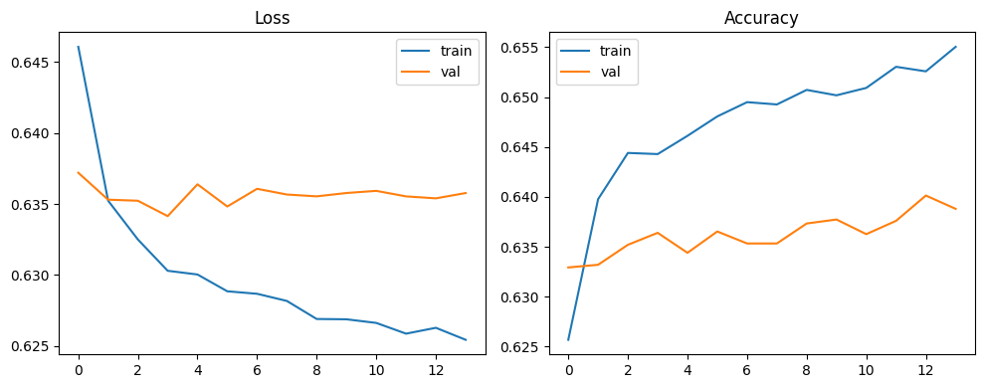
Spindle_Speed 0.058838
Vibration_Level 0.021055
Dimensional_Error 0.021049
Tool_Wear 0.010919
Operator_Experience 0.004691
Surface_Roughness 0.003992
Inspection_Time 0.000543
Feed_Rate 0.000415
Material_Hardness 0.000364
Shift 0.000308
Machine_Temperature 0.000248
Machine_ID 0.000170
Coolant_Temperature 0.000111
Humidity -0.000005
Cutting_Speed -0.000076
Power_Consumption -0.000187
Material_Thickness -0.000192
Ambient_Temperature -0.000463
dtype: float64
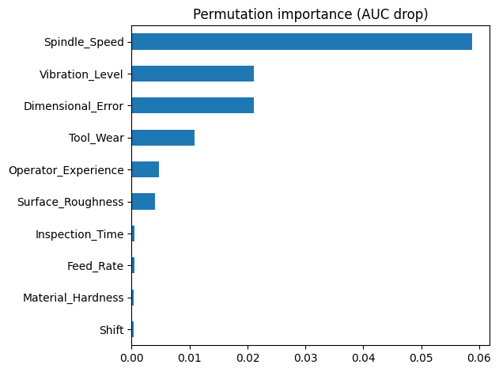
Tool_Wear
(-0.001, 20.0] 0.393057
(20.0, 40.2] 0.477974
(40.2, 59.94] 0.573088
(59.94, 80.0] 0.645846
(80.0, 100.0] 0.727866
Name: Fail, dtype: float64
Spindle_Speed
(1483.999, 3072.0] 0.434096
(3072.0, 3370.0] 0.505938
(3370.0, 3623.0] 0.571314
(3623.0, 3923.0] 0.617191
(3923.0, 5810.0] 0.689071
Name: Fail, dtype: float64
Vibration_Level
(0.499, 1.82] 0.464300
(1.82, 2.29] 0.521263
(2.29, 2.7] 0.566438
(2.7, 3.18] 0.607759
(3.18, 5.82] 0.658935
Name: Fail, dtype: float64
Defect_Type
Crack 2865
Dent 9172
Porosity 6271
Scratch 9864
dtype: int64

